Assessment #2 - Step 7
For step seven, I have chosen the following three products:
- Broan 30 inch stainless steel rangehood,
- Broan exhaust fan with light, and
- Broan one-bulb heater and fan
These products are manufactured by Broan, a subsidiary of Melrose PLC that specializes in residential air systems. Broan has assets located across the world. I chose to use Broan’s products for this assessment as I can relate to their products better and can price there products more accurately than many of Melrose’s other subsidiaries. Much of the other subsidiaries are focused on commercial products such as Aerospace products, electricity generation etc.
I have estimated the selling price on these products based on the retail price set by Walmart (all prices are in $USD). Here are snips of my screen to support my prices.
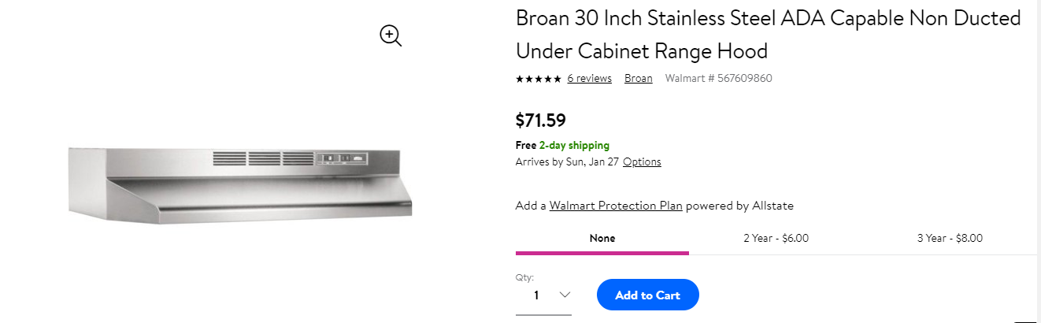
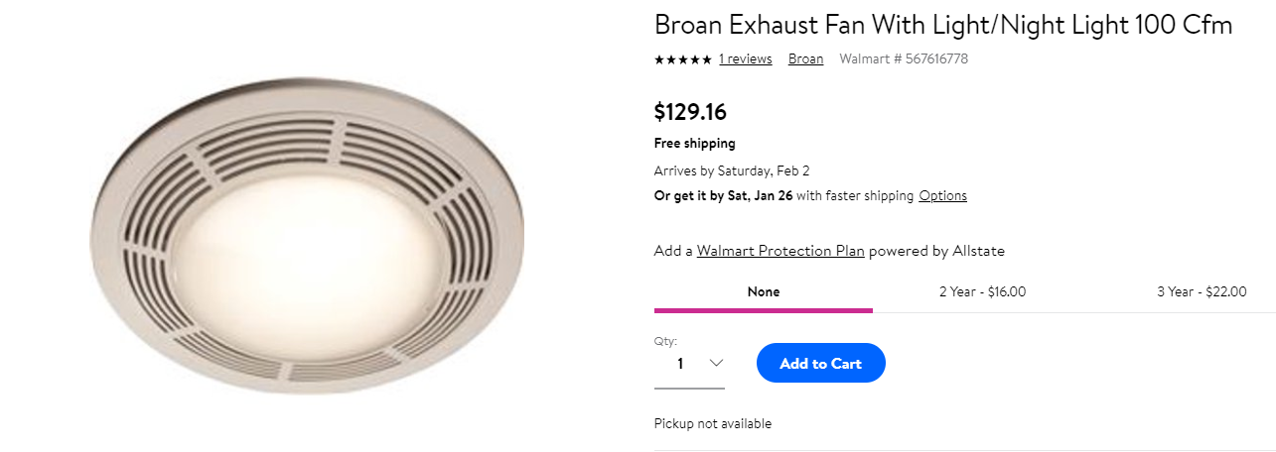
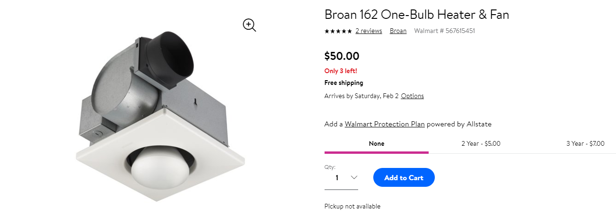

I have estimated that Broan may sell these products wholesale for about 60% of the retail price. So, I have multiplied the retail price by 60% to estimate how much Broan may wholesale them for. My calculations are as follows (these figures are in the respective order as my chosen products listed earlier):
- $71.59 × 0.6 ≈ $42.95
- $129.16 × 0.6 ≈ $77.50
- $50 × 0.6 = $30
Now that I have estimated the selling price of these goods, I will need to estimate the variable costs associated with them. Broan produces goods at a relatively high volume, however, a large portion of the costs associated with the goods will be related to the factories and the machinery in the factories. These are both fixed costs, so variable costs will be relatively small. I am going to use 65% of the selling price as my estimate of variable costs.
- $42.95 × 0.65 = $27.92
- $77.50 × 0.65 = $50.38
- $30 × 0.65 = $19.50

Now that we have the variable costs, we can calculate the contribution margin of each unit using the following formula:
$$CM=S-VC$$
Contribution margin of Broan 30-inch stainless steel rangehood:
$$CM=S-VC$$
$$=\$42.95-\$27.92$$
$$=\$15.03$$
Contribution margin of Broan exhaust fan with light:
$$CM=S-VC$$
$$=\$77.50-\$50.38$$
$$=\$27.12$$
Contribution margin of Broan one-bulb heater and fan:
$$CM=S-VC$$
$$=\$30-\$19.50$$
$$=\$10.50$$

Each unit will contribute the contribution margin towards the fixed costs, with a small portion being left over to contribute towards profits. The fixed costs for Broad are likely to be substantial, as it will include the land, buildings, machinery, electricity, insurance, advertisements etc.
I do not believe there to be any major scarcity of resources in the manufacture of these products. I think the largest limitation is the demand for the product itself rather than being limited by resources. This is because these products are consumed relatively infrequently by customers. Consumers are not going to use as many exhaust fans as something like loafs of bread or even many other electrical appliances, they are simply replaced fairly infrequently. There is also quite a large amount of competition in the market, further reducing the quantity demanded from the firm.
Broad must maintain a diverse portfolio of products in order to remain competitive. Not all customers need an exhaust fan and a light, however some need both. If Broad only sold one variation of their products and the consumers needs differed from what they could get from the appliance, they would simply purchase goods from another manufacturer. It is particularly necessary to appeal to as many customers as possible in order to maintain the necessary economy of scale required by such an industry. Because of this, selling only one line of products would likely mean that there will be limited sales. Therefore, the income from the contribution margins will not be sufficient to cover the fixed cost and the company would be operating on a loss.
The contribution margins of the products I have chosen indicates that the most profitable product to distribute would be Broan exhaust fan with light. The most profitable approach for Broad would be to manufacture as much of this product as they can sell, then manufacture as much of 30-inch stainless steel rangehood as can be sold, finally, manufacture as much one-bulb heater and fan as can be sold. If possible, focus as much of the advertising and marketing towards the exhaust fan to increase demand for the product.

